Final Year Project


Software Requirement Specification BioMechAI
FYP Team Muhammad Abdullah (22F-3444) Abdul Hanan Nadeem (22F-8762)
Zainab Haider (22F-8818)

Supervised By
Mr. Mughees Ismail

Co-Supervised By

Dr. Muhammad Usama


Department of Computer Science
FAST – National University of Computer & Emerging Sciences Chiniot-Faisalabad Campus
2026

Table of Contents

- Introduction 1
- Vision Document 2
  - Problem Statement 2
  - Business Opportunities 3
  - Objectives 3
  - Scope 4
  - Constraints 4
  - Stakeholder and User Description 5
    - Market Demographics 4
    - User Environment 5
    - Stakeholder Profiles 8
    - Stakeholder Summary 8
- System Requirements Specification 9
  - System Features 9
  - Functional Requirements 11
    - Real-time 3D Pose Detection. 11
    - Exercise Recognition and Classification 11
    - Real-time Rep Counting and Form Validation 12
    - Posture Correctness 13
    - Body Measurement and Transformation Tracking 14
    - AI Injury Prediction 15
    - AI Workout Companion with Voice Conversation. 16
    - Trainer Dashboard 16
  - Non-Functional Requirements 17
    - Performance 17
    - Usability. 17

    - Reliability 17
    - Security and Privacy 17
    - Compatibility 18
- Project Artefacts 19
  - Use Case Models 19
  - Structural Design 34
  - Behavioral Design: 37
  - Maintenance Phase 40
List of Tables:

Table 1: Problem Statement 2

Table 2: Supervisor Team 6

Table 3: Development Team 6

Table 4: End Users 7

Table 5: Certified Trainers 7

Table 6: Admin 8

Table 7: Stakeholder Summary 8

Table 8: Register and Login User 20

Table 9: Track Body Measurements 20

Table 10: Detect Real-Time 3D Pose 21

Table 11: Recognize Exercise 21

Table 12: Assist Via Voice 22

Table 13: Provide Posture Correction and Feedback 22

Table 14: Count Reps and Validate Form 23

Table 15: Predict Injury 23

Table 16: Manage User. 24

Table 17: View Reports 24

Table 18: Access Trainer Dashboard. 25

Table 19: High-Level Use Case 26

List of Figures:
Figure 1: Use Case Diagram 19
Figure 2: Swimlane Activity Diagram 28
Figure 3: System Sequence Diagram 01 - Body Measurement Tracking 29
Figure 4: System Sequence Diagram 02 - Exercise Recognition 29
Figure 5: System Sequence Diagram 03 - Injury Prediction 30
Figure 6: System Sequence Diagram 04 - Pose Detection 30
Figure 7: System Sequence Diagram 05 - Posture Correction 31
Figure 8: System Sequence Diagram 06 - Rep Counter 31
Figure 9: System Sequence Diagram 07 - Trainer Dashboard 32
Figure 10: System Sequence Diagram 08 - User Registration and Login 32
Figure 11: System Sequence Diagram 09 - Voice Companion 33
Figure 12: Domain Model 34
Figure 13: Class Diagram 35
Figure 14: Component Diagram 36
Figure 15: DFD Level 0 37
Figure 16: DFD Level 1 37
Figure 17: State Machine Diagram 38
Figure 18: Sequence Diagram 39
Figure 19: Deployment Diagram 40

Introduction
BioMechAI is created to solve an important problem in personal fitness: many people do not have an easy way to check whether they are performing exercises with the correct form in real time, which can increase the chances of workout-related injuries. This section introduces the main goals and reasons behind developing this system.
In addition, this Software Requirements Specification (SRS) clearly describes the system’s functional requirements (what the system should do) and non-functional requirements (how well the system should perform). It also includes the use case models and the guidelines for designing artifacts that will be used while building the BioMechAI system. For the final graduation defence of FYP-2, the project is structured into the following nine comprehensive modules:
- Module 1: User Registration and Login
- Module 2: Real-time 3D Pose Detection
- Module 3: Exercise Recognition and Classification
- Module 4: Real-time Rep Counting and Form Validation
- Module 5: Posture Correctness (Four-Pattern Form Correction)
- Module 6: Body Measurement and Transformation Tracking
- Module 7: AI Injury Prediction
- Module 8: AI Workout Companion with Voice Conversation
- Module 9: Trainer Dashboard.

Vision Document

Problem Statement:

Table 1: Problem Statement

Category | Description
Problem | Personal training sessions are expensive, and many users cannot afford them, as a single session can cost a large amount of money.  Around 45% of people who go to the gym experience injuries because they perform exercises with the wrong form and there is no system to correct them instantly.  Most fitness applications only provide general workout plans. They are not personalized and do not give real-time 3D feedback about body movement during exercises.
Affects | People of all fitness levels who want to exercise safely and improve their training.  The wider health and fitness community, including physiotherapists, fitness coaches, and sports medicine professionals.
Impact | Leads to avoidable injuries, extra medical costs, and people training on their own without proper guidance.  Creates a gap in preventive health because there are very few affordable tools that combine movement analysis with personalized coaching.
Solution | An AI-powered personal fitness trainer that works on a smartphone and uses real-time movement analysis. The system will:  Provide real-time 3D pose correction and recognize the exercise being performed.  Automatically count repetitions while checking if the exercise form is correct.  Analyze movement patterns during workouts to predict possible injury risks.  Include a real-time on-device voice coaching companion that delivers instantaneous, priority-debounced auditory safety cues, rep milestones, and recovery praise during active exercise.  Work completely on normal smartphones, so users do not need expensive  or specialized equipment.

Business Opportunities
BioMechAI aims to solve an important problem in accessible personal fitness while also creating a strong business opportunity. The system can support a premium subscription model for users and also allow partnerships with rehabilitation clinics, sports academies, and corporate wellness programs. Through these partnerships, this application can provide scalable AI-based coaching that analyzes body movement and exercise form.

Objectives
Following are the objectives of BioMechAI:
- Develop a real-time 3D pose detection system that can run smoothly on normal smartphones and accurately track the user’s body movements.
- Provide a form validation system that checks movement patterns to make sure exercises are performed safely, with correct posture, and flags movements that may cause injury.
- Provide certified personal trainers with a dedicated dashboard so they can manage, review, and guide their remote clients using AI-supported workout videos.
- Implement automatic exercise classification across seven (7) core fundamental gym exercises utilizing a 3D spatiotemporal convolutional neural network (PoseC3D SlowOnly ResNet-50) pretrained on athletic video datasets (NTU RGB+D / FineGYM) and fine-tuned on the BioMechAI dataset.
- Allow users to monitor their physical transformation through an anthropometric measurement tracking feature calibrated by user height, live Body Mass Index (BMI) computation, and the clinical Devine Ideal Body Weight formula.
- Build a dual-horizon AI injury prediction engine that detects acute joint collapse in real time (e.g., dynamic knee valgus <165° for ACL injury, lumbar hip sag for spinal disc compression, and shoulder flare for impingement) while logging inter-session fatigue trends.
- Introduce a real-time, on-device AI voice companion that provides sub-10ms priority-preempted audio corrections and form encouragement without requiring an active internet connection.

- Use optimization methods so that all AI models run efficiently and respond in real time on mid-range smartphones, ensuring a smooth experience.

Scope
The scope of BioMechAI includes developing a complete personal fitness platform that focuses on real-time 3D body movement analysis, exercise recognition with form checking, AI-based injury prediction, and conversational coaching. The system is architected as a high-performance Flutter mobile application for athletes and personal trainers, communicating via high-speed WebSockets and REST APIs with a dedicated PyTorch/FastAPI backend inference engine for deep spatiotemporal neural network evaluation.

Constraints
- AI model sizes must stay under 50MB on the device after INT8 quantization to comply with app store limits.
- During academic testing, the Firebase free tier restricts the number of concurrent users to about 50-100 active users.
- On-device AI processing (pose estimation, rep counting, kinematic form validation) must execute within 15ms per frame on mid-range devices (Snapdragon 720G or equivalent) to sustain 30 FPS camera capture.
- Deep learning spatiotemporal inference (PoseC3D) requires a GPU-enabled backend server (NVIDIA T4 or equivalent) for batched 3D convolutional tensor evaluations within 45ms.
- Anthropometric body tracking relies on standardized vertical user framing and calibrated reference stature (height) for metric conversion.
- Acute injury prediction operates instantaneously on every single repetition using clinical kinematic angle cutoffs (e.g., Munro FPPA
<165.0°<165.0° for knee valgus), while chronic overuse trends require
cumulative multi-session logs.

Stakeholder and User Description

Market Demographics
The primary target market for this app includes fitness-conscious individuals aged 16 to 45 who exercise on their own, either at home or in gyms, without regular access to personal trainers. Secondary markets include certified fitness trainers who want AI-assisted tools to manage and monitor clients, physiotherapists who use movement analysis for rehabilitation, and sports academies focused on tracking athletes’ form and performance. In Pakistan and South Asia, BioMechAI’s smartphone-based approach makes professional fitness guidance more affordable, helping users overcome economic barriers.

User Environment
End users interact with BioMechAI through the Flutter mobile app on Android or iOS smartphones. They perform workouts in different settings such as homes, gyms, or outdoor spaces, with the phone placed 1.5-3 metres away on a stand or flat surface. Trainers access the system through a dedicated Flutter Mobile Trainer Portal. On-device AI processing (Google ML Kit pose detection, Closed 4-Stage Rep FSM, Four-Pattern Kinematics, and flutter_tts voice coaching) operates fully autonomously with sub-15ms frame latency without requiring an active internet connection. Dedicated GPU cloud inference (PoseC3D spatiotemporal model on FastAPI) and Firebase Firestore synchronization activate when network connectivity is available, providing seamless offline-first capability.

Stakeholder Profiles
      - Supervisor Team
Table 2: Supervisor Team

Representatives | Supervisor: Mr. Mughees Ismail Co-Supervisor: Dr. Muhammad Usama
Description | Supervise development activities and ensure academic standards are maintained
Type | Technical Stakeholders
Responsibility | - Give directions to the development team  - Ensure timely completion  - Review project deliverables and documentation Track development tasks  Ensure product meets academic standards
Success Criteria | Completion of features committed by the development team at the start of the project
Involvement | - Requirement reviewer  - Senior managers  - Review project progress
Comments/Issues | None

Development Team
Table 3: Development Team

Representatives | Muhammad Abdullah, Muhammad Abdul Hanan Nadeem, Zainab Haider
Description | Responsible for full development, documentation, testing, and deployment of BioMechAI
Type | Technical stakeholders

Responsibility | - Develop the system across mobile and web platforms  - Create and maintain comprehensive documentation  - Test AI models and app features  - Deploying the final product
Success Criteria | Deliver a fully functional, responsive application that meets all functional and non-functional requirements
Involvement | - Full involvement in all phases of SDLC  - System design and implementation  - Quality assurance and debugging
Comments/Issues | None

End Users
Table 4: End Users

Representatives | General public / Fitness enthusiasts
Description | Primary users utilizing the mobile app to exercise safely and track physical progress
Type | Non-technical Stakeholders
Responsibility | - Use app for real-time fitness tracking and form validation  - Provide feedback on usability and features  - Report operational issues
Involvement | - Beta testing  - User Acceptance Testing (UAT)  - Providing usability feedback
Comments/Issues | None

Certified Trainers
Table 5: Certified Trainers

Representatives | Professional fitness coaches
Description | Fitness professionals using the dedicated Flutter Mobile Trainer Portal to remotely manage clients
Type | Domain-expert Stakeholders
Responsibility | - Monitor remote clients’ workout progress  - Review AI annotations and 3D pose data  - Generate performance reports and adjust training plans
Involvement | - Field testing of the mobile trainer portal  - Validation of four-pattern form correction
Comments/Issues | None

2.6.3.5 Admin
Table 6: Admin

Representatives | Admin
Description | Oversees backend operations, database management, and system stability
Type | Technical Stakeholder
Responsibility | - Manage user and trainer accounts  - Monitor system health, Firebase usage, cloud latency  - Ensure data security and backend stability
Involvement | - Backend administration  - System and database monitoring  - Deployment maintenance
Comments/Issues | None

Stakeholder Profiles

Table 7: Stakeholder Summary
Name | Description | Responsibility
Development Team | The development team handles all phases of the project, including planning, building, testing, and documenting BioMechAI. | Fully involved in the development of the project. Specify the  requirements, develop system features, test functionality, and ensure the final product works as intended.
Supervisor Team | Academic supervisors guide and support the development team to ensure quality and timely completion. | Provide technical guidance and review deliverables to help the team complete the project successfully.
End User | Individuals who will use the BioMechAI app to exercise safely and track progress. | Use the app responsibly, provide feedback on usability, and report any issues during workouts.
Admins | System administrator responsible for backend operations and system health. | Manage user accounts, monitor system performance, and ensure smooth operation of the backend.
Certified Trainers | Fitness professionals who will use the Trainer Dashboard to manage clients. | Monitor clients remotely, review all the AI-generated insights, and provide guidance to improve training outcomes.

System Requirements Specification

System Features
BioMechAI delivers the following core system features across its nine (9) verified production modules:
- User Registration and Login: Implements hardened role-based authentication partitioning Athletes and Certified Trainers across Mobile and Web (biomechai-fitness). Enforces a mandatory Email Verification Security Gatekeeper where registration triggers native email verification links and immediately terminates unverified sessions. Integrates an automatic Session Persistence Engine with a 3.0s background watchdog, allowing verified users to stay logged in across app restarts without retyping credentials.
- Real-time 3D Pose Detection: Extracts 33 normalized 3D anatomical landmarks at 30 FPS using Google ML Kit BlazePose running natively on-device with custom low-latency visual skeleton overlays.
- Exercise Classification (PoseC3D Deep Learning Engine): Classifies user movement into seven (7) fundamental exercises using a 3D spatiotemporal ResNet-50 network fine-tuned on athletic limb heatmaps, achieving 91.22% Top-5 accuracy on held-out test splits.
- Real-time Rep Counting & Isometric Hold Timer: Employs a deterministic Closed 4-Stage Repetition Finite State Machine (START → INFLECTION → PEAK → COMPLETION) with
camera boundary occlusion rejection for dynamic exercises. For static holds (Plank), features a Posture-Gated Isometric Hold Timer adhering to the McGill (2010) clinical spine standard (150°–195° body line angle), automatically pausing the timer and illuminating a red skeleton on hip sag or pike, and calculating posture-weighted continuous scores (Score=totalTimevalidHoldTime ×100).
- Posture Correctness (Four-Pattern Kinematic Engine): Evaluates sagittal depth flexion, frontal knee alignment, trunk neutrality, and framing sanity in <0.1ms using clinically validated vector trigonometry.

- Smart Anthropometric Scanner & Assessment PDF Engine:
Monocular photogrammetry engine utilizing the user's entered stature as
a calibration anchor (scale=heightCm/bodyPxscale=heightCm/bodyPx). Integrates a Smart Distance-Guiding Auto-Scanner with real-time video stream processing at 30 FPS, dynamic color-coded framing cues (Red:
<0.55 too far, >0.92 too close; Green: 0.65−0.85 ideal zone), a 3-second hold countdown, and instant Euclidean joint span extraction (Shoulder Width, Hip Width, Torso Length, Arm Reach). Includes Cross-Platform Assessment PDF Generation providing branded clinical progress reports on mobile and web.
- AI Clinical Injury Prevention Engine: Real-time multi- joint clinical injury prevention engine covering all 7 exercises: Munro Dynamic Knee Valgus FPPA (<165.0° <165.0°) for acute ACL risk (Squat/Lunge), lumbar hip sag (>10%>10% below line) for spinal compression (Push-Up/Plank), and elbow flare (>65.0°>65.0°) for shoulder impingement (Push-Up). Backed by an Edge-Cloud Zero-Fail Hybrid Fallback Shield: if cloud connectivity drops, the local mobile kinematic engine instantly assumes full responsibility, turning the skeleton Crimson Red and firing priority-preempted audio safety warnings offline without frame drops.
- AI Workout Companion with Live Voice Coaching: Provides zero-latency, on-device audio coaching (flutter_tts) governed by a 3-tier priority queue (Priority 1: Emergency Safety Warnings, Priority 2: Rep Milestones, Priority 3: Form Praise) with dynamic cooldown debouncing.
- Trainer Dashboard, Two-Way Pairing & Feedback Hub: A unified multi-tenant coaching platform connecting the Flutter mobile app and React Web Portal (biomechai-fitness). Implements Two-Way Sovereign Pairing where coaches invite athletes by email, athletes accept/decline via in-app invitation cards, and either party can unlink at any time with multi-coach data isolation. Features an active Unread Feedback Bell Badge lighting up with unread counts (1, 2) on the mobile home screen, paired with 1-Tap Direct Session Navigation that deep- links directly from notifications into the exact workout session details screen.

Functional Requirements
The system must fulfil specific functional requirements, including:

Real-time 3D Pose Detection:
      - The system shall capture live workout frames from the front/back mobile camera at 30 frames per second.
      - The system shall detect 33 normalized 3D anatomical body landmarks (x,y,z) in real time using Google ML Kit BlazePose executing natively on-device.
      - The system shall render a color-coded kinematic skeleton overlay on the live camera feed using Flutter CustomPainter, keeping rendering latency below 15 milliseconds.
      - The system shall buffer joint coordinate streams in a 48-frame rolling spatiotemporal window for deep convolutional exercise classification.
      - The system shall utilize MediaPipe's relative 3D z-depth coordinate estimates to measure sagittal-plane depth and forward torso inclination across standard monocular smartphone cameras without requiring specialized LiDAR hardware.

Exercise Recognition and Classification
      - The system shall recognize seven (7) core athletic compound and isolation exercises: Squat, Push-Up, Lunge, Bicep Curl, Plank, Jumping Jack, and High Knees.
      - The system shall convert 48 consecutive frames of 17-channel COCO anatomical joint coordinates into spatiotemporal 3D limb heatmaps (56×56×48) with Gaussian tubular segments (σ=0.6).
      - The system shall classify the spatiotemporal volume using a SlowOnly ResNet-50 3D convolutional neural network (PoseC3D) initialized with pretrained athletic weights (NTU RGB+D / FineGYM) and fine-tuned on the BioMechAI dataset (91.22% Top-5 accuracy, 53.38% Top-1 record on held-out test splits).
      - Data Engineering & Dataset Scaling (Phase v7 Expansion): To ensure high generalization across diverse gym environments and athletic builds, the training corpus was scaled to 5,602 total spatiotemporal clips

(4,434 training, 1,168 validation across 1,009 source videos). An industrial 4-layer duplicate and leakage defense was implemented:
      - Global URL Archive: Hash-indexed download cache preventing redundant
video ingestion.
      - Temporal Windowing: Non-overlapping spatiotemporal slice extraction.
      - Near-Duplicate Frame Scrubbing: Stringent rejection of clips sharing ≥20≥20 frames with validation sets.
      - Quality & Occlusion Filtering: Out-of-frame tolerance capped at 25%25% and minimum motion floors (>1.0>1.0) enforced for isometric holds.
Following deduplication, the verified training set comprises 3,159 unique clips
(a 4.3× expansion over baseline), evaluated against the strictly frozen 115
held-out videos zero-leakage benchmark (444 clips, 91.22% Top-5 accuracy).
      - Classification decisions shall be locked when model softmax probability exceeds the calibrated deployment threshold (T=0.50). After recognition, the system shall dynamically switch kinematic form validation rules and audio coaching prompts specific to the recognized exercise.

Real-time Rep Counting & Plank Isometric Timer and Form Validation
      - The system shall track primary biomechanical joint articulations in real time
(knee flexion for squats/lunges, elbow flexion for push-ups/curls, hip height for planks).
      - For static isometric exercises (Plank), the system shall track continuous hold duration, gating the active timer to valid spinal posture (body line angle between 150.0° and 195.0°). The timer shall pause immediately when posture deviates
into hip sag (<150.0°) or hip pike (>195.0°), and calculate final session scores weighted by valid hold percentage.
      - The system shall record distinct exercise blocks chronologically within a single workout session, logging start times, end times, individual rep counts, hold durations, and separate form scores for post-workout timeline inspection.

      - The system shall implement a deterministic Closed 4-Stage Repetition Finite
State Machine (FSM):
- START: Baseline standing posture (θ≥146.0°).
- INFLECTION: Descent phase initiated (θ<146.0°).
- PEAK: Valid exercise depth attained (e.g., knee flexion ≤115.0° for squats, elbow flexion ≤95.0° for push-ups).
- COMPLETION: Full extension restored (θ≥146.0°), incrementing rep count by exactly +1.
  - Repetitions failing to reach the required peak depth threshold shall be classified as partial/incomplete reps and rejected without incrementing the counter.
  - The system shall enforce an anatomical sanity floor (θ≥35.0°) to discard sudden optical occlusion glitches.
  - During workouts, the system shall display the validated repetition count, real-time joint angles, and active form status flags.

Posture Correctness
The system shall evaluate exercise posture using a Four-Pattern Clinical Kinematic Vector Engine based on peer-reviewed biomechanical literature:
- Sagittal Depth Flexion: Measures target joint extension/flexion using vector dot products against gold-standard standards (Schoenfeld 2010, Escamilla 2001).
- Frontal Plane Projection Angle (FPPA): Monitors medial-lateral deviation of the knee joint relative to the hip-ankle line (Munro et al. 2012).
- Trunk and Spinal Neutrality: Computes pelvic-shoulder angle relative to the gravity axis to detect compensatory lumbar hyperextension or excessive forward lean (McGill 2010).
- Camera Framing Guards: Filters out landmark estimates whenever key tracking joints intersect camera borders (y>0.94y>0.94).
- The system shall render real-time color-coded skeleton feedback
(green = acceptable form, red = kinematic violation) alongside corrective text overlays and priority audio coaching cues.

Body Measurement and Transformation Tracking
        - The system shall provide an Anthropometric Body Measurement and Transformation Tracking interface.
        - The system shall calculate Body Mass Index (BMI) dynamically from recorded weight and height using the World Health Organization (WHO TRS 854) standard: BMI=weight (kg)/(height (m))2BMI=weight (kg)/(height (m))2.
        - The system shall render an interactive color-coded BMI gauge with medical classification bands: Underweight (<18.5<18.5, blue), Normal (18.5–24.918.5–24.9, green), Overweight (25.0–29.925.0–29.9, yellow), and Obese (≥30.0≥30.0, red).
        - The system shall compute the user's physiological Ideal Body Weight (IBW) baseline using the clinical Devine Formula: IBW=50.0 kg+2.3×(height in inches−60)
        - The system shall persist longitudinal transformation logs in Cloud Firestore and plot historical weight trends over time.
        - The system shall process live camera frames at 30 FPS to calculate vertical body span (span=∣yankle−ynose∣/Hframe ) and provide real-time color-coded framing cues (Red: <0.55 or >0.92; Green: 0.65−0.85 ideal zone). Upon detecting 3.0 seconds of stable ideal framing, the system shall capture landmark coordinates with zero shutter lag.
      - The system shall calculate real-world physical dimensions (Shoulder Width, Hip Width, Torso Length, and Arm Span) in centimeters using the user's calibrated height ratio.
      - The system shall generate comprehensive, clinically styled fitness assessment reports in PDF format on both mobile (PdfReportService) and web (jsPDF). The generated assessment shall automatically populate:
      - Calibrated Anthropometric Levers: Real-world Euclidean dimensions (Shoulder
Width, Hip Width, Torso Length, and Arm Span in cm) extracted by the smart camera auto-scanner.
      - Physiological Vitals & Indices: Height, weight, WHO BMI classification gauge, and Devine Ideal Body Weight target range.

      - Granular Multi-Exercise Breakdown Table: Exercise-by-exercise chronological summary logging completed reps, valid/invalid breakdown, isometric hold durations, and specific kinematic fault annotations across all exercises in the session.

AI Injury Prediction
      - The system shall maintain an edge-cloud hybrid kinematics pipeline. If the cloud inference server or network tunnel becomes unreachable, the on-device kinematic engine shall autonomously handle real-time form validation, illuminating the skeleton Crimson Red on detected faults and outputting local text-to-speech audio warnings without latency degradation.
      - The system shall implement a Dual-Horizon AI Clinical Injury Prevention Engine protecting upper body, core/spine, and lower body joints across all 7 exercises:
      - Acute Knee Valgus / ACL Tear Risk (Squats & Lunges): Continuously evaluates Munro Frontal Plane Projection Angle. An acute alert is triggered when FPPA<165.0° under active flexion load (≤130.0°), preventing non-contact ACL rupture (Munro 2012, Hewett 2005).

Lumbar Disc Shear & Compression Risk (Push-Ups & Planks): Calculates
perpendicular orthogonal distance from hip joint to shoulder-ankle axis. Sagging exceeding 10% of body length triggers an immediate spinal safety alert (McGill 2010).
      - Subacromial Shoulder Impingement Risk (Push-Ups): Measures humeral abduction angle relative to torso axis. Elbow flare exceeding 65.0° triggers an acute warning to prevent supraspinatus tendon pinching (Flatow 1994, Cogley 2005).
      - Bicipital Tendon & Lumbar Strain Risk (Bicep Curls): Flags forward elbow drift >30.0° and backward torso swing >20.0°
      - Iliopsoas & Lower Back Compensation (High Knees): Flags excessive forward trunk lean >15.0°. The system shall log cumulative repetitions performed with hazardous kinematics to assess longitudinal joint fatigue trends.

AI Workout Companion with Voice Conversation
      - The system shall provide an on-device AI Voice Coaching Engine powered by flutter_tts operating completely offline with sub-10 millisecond latency.
      - Audio cues shall be dispatched using a strict 3-tier Priority Preemption Queue:
      - Priority 1 (Emergency Safety Alerts): Immediate voice override for acute injury risks ("Push your knees out!", "Lift your hips!", "Tuck your elbows!").
      - Priority 2 (Repetition Milestones): Auditory rep count announcements ("Rep 5 completed").
      - Priority 3 (Form Praise & Recovery): Positive encouragement when safe form is maintained or restored ("Great depth, keep going!").
      - The engine shall implement dynamic cooldown debouncing (minimum 2.5 seconds between duplicate cues) to prevent auditory flooding.
      - An asynchronous 3.0-second hardware watchdog timer shall monitor audio speech completion to prevent mobile audio channel deadlocks.

Trainer Dashboard
      - The Trainer Dashboard shall be a specialized portal within the Flutter mobile application, secured via Firebase Authentication role separation (role: 'trainer').
      - The dashboard shall display a real-time client roster showing client workout history, average form compliance scores, and completed repetition totals.
      - Trainers shall be able to select any client session and attach second-by-second timestamped coaching feedback (e.g., linked to specific rep timestamps) stored in Cloud Firestore.
      - Athletes shall receive and view these coach annotations directly within their personal workout summary views.
      - The system shall enforce two-way pairing consent: coaches dispatch email invitations via the web dashboard, athletes receive interactive in-app invitation cards with [Accept] and [Decline] actions, and either party can disconnect at any time to preserve client autonomy and multi-tenant data isolation. Furthermore, the web application (biomechai-fitness.web.app) shall dynamically support Dual-Role Navigation: Certified Trainers access the client roster and feedback composer, while Athletes logging in via web browsers can inspect their personal workout history, review coach feedback via a dedicated Web Notifications Center, and manage pairing status independently.

      - The mobile application shall maintain an unread trainer feedback counter in local device storage, dynamically rendering a numeric badge (1, 2) over the home screen notification bell icon upon receiving new coach feedback. Selecting a feedback item shall deep-link directly to that specific workout session's details screen with the highlighted coach feedback card.

Non-Functional Requirements

Performance
      - On-device pose estimation and kinematic form feedback shall execute within 15 milliseconds per frame on standard Android devices (Snapdragon 720G or equivalent), sustaining 30 FPS camera capture without frame drops.
        - Spatiotemporal 3D convolutional classification (PoseC3D) evaluated on the Python FastAPI inference server shall return top-class predictions within 45 milliseconds per 48-frame clip.
        - Exercise recognition shall establish confirmed exercise lock within 2.0 seconds of steady motion using a 48-frame rolling buffer.

Usability
      - New users shall be able to complete onboarding and start their first workout within 5 minutes.
      - Visual correction guidance shall be clear enough to understand without reading text, using icons and color-based overlays.

Reliability
      - Main on-device features such as pose detection, repetition counting, and form validation shall work even without an internet connection.
      - The system shall handle camera interruptions like calls or notifications smoothly and resume pose detection within 2 seconds.

Security and Privacy
      - All user body data, photos, and workout history shall be encrypted during transfer (TLS 1.3) and while stored in Firestore.
      - Workout video data used for form analysis shall not be saved on servers unless the user gives clear permission.
      - Firebase Authentication shall require strong passwords and also support OAuth
2.0 social login options.

Compatibility
      - The mobile application (both Athlete and Trainer modes) shall support devices running Android 8.0 (API Level 26) or higher and iOS 14.0 or higher.
      - All on-device AI modules (Google ML Kit pose detection, Closed 4-Stage Rep FSM, Four-Pattern Kinematics, flutter_tts Voice Coaching) shall run efficiently on devices with at least 3GB RAM and Snapdragon 660 or higher without thermal throttling.
      - The dedicated PyTorch backend service shall run on any Linux or Windows environment equipped with Python 3.10+ and CUDA-capable GPU acceleration (or CPU fallback).

Project Artefacts
The following artefacts must be developed and approved by the supervisor:

Use Case Models:

Use Case Diagram:
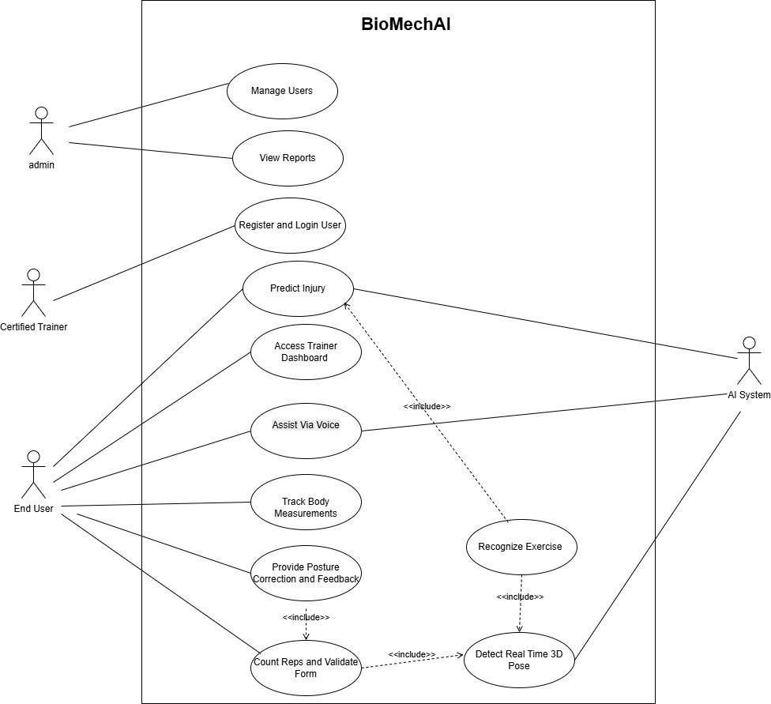
Figure 1: Use Case Diagram

Expanded Use Cases:

Table 8: Register and Login User

Use Case ID | UC-01
Use Case Name | Register and Login User
Primary Actor | End User
Module | Module 1
Description | The user creates an account using email or social login and sets up a personal profile by entering body details.
Preconditions | The user has a smartphone with the BioMechAI app installed.
Postconditions | A user account is successfully created and stored in Firebase Authentication and Firestore.
Main Flow | - User enters name, email, password, height, weight, age, and selects role (Athlete vs Trainer).  - System validates input formats and creates an authentication record in Firebase Auth.  - System automatically dispatches a verification link to the user's email inbox via sendEmailVerification().  - System immediately terminates the unverified session and redirects to the Login screen with an alert: "Verification email sent. Please verify before signing in."  - User clicks the verification link in their email client.  - User enters credentials on the Login screen; System reloads user profile, verifies emailVerified == true, and grants access to the dashboard.
Exceptions | - System intercepts the attempt, denies login,  terminates session, and displays an interactive "Resend Verification Link" button.  - On application relaunch, system verifies cached token in background with a 3.0s watchdog, bypassing credentials input for verified users.

Table 9: Track Body Measurements

Use Case ID | UC-02
Use Case Name | Track Body Measurements
Primary Actor | End User
Module | Module 1
Description | The user records body measurements and tracks progress.
Preconditions | The user is logged in, and a profile exists.
Postconditions | Measurements are saved, and progress charts are updated.

Main Flow | - The user opens the Body Measurements section.  - The user selects Add Measurement.  - The user enters body measurement details.  - The system validates the entered data.  - The system calculates BMI and related metrics.  - The system saves the measurement record.  - The system updates and displays progress charts.

Table 10: Detect Real-Time 3D Pose
Use Case ID | UC-03
Use Case Name | Detect Real-Time 3D Pose
Primary Actor | End User
Module | Module 2
Description | The system captures live videos and detects body landmarks in real time to show a 3D skeleton overlay.
Preconditions | The user is logged into the app and has allowed camera access.
Postconditions | A skeleton overlay is shown on the camera screen in real time and joint movement data is stored in memory.
Main Flow | - The user starts a workout session.  - The camera begins capturing video at about 30 frames per second.  - MediaPipe Pose Lite detects 33 body landmarks with X, Y, and Z coordinates.  - The system displays a skeleton overlay on the live camera feed using OpenGL.  - Joint position data is stored in a 90-frame in-memory buffer for further analysis.

Table 11: Recognize Exercise
Use Case ID | UC-04
Use Case Name | Recognize Exercise
Primary Actor | AI System
Module | Module 2
Description | The AI system identifies the exercise being performed using pose data.
Preconditions | 3D pose tracking is active and the exercise model is loaded.
Postconditions | The exercise is identified and displayed to the user.
Main Flow | - The system receives joint data.  - The system collects movement data.  - The model analyzes the movement pattern.  - The model compares it with known exercises.  - The system selects the best matching exercise.  - The system returns the exercise type.  - The system displays the exercise name and confidence level.  - The system configures rep counting and posture settings.

Table 12: Assist Via Voice

Use Case ID | UC-05
Use Case Name | Assist Via Voice
Primary Actor | End User
Module | Module 3
Description | The voice assistant provides workout feedback and responds to voice commands.
Preconditions | The user is logged in, a workout session is active, and voice access is enabled.
Postconditions | Voice feedback is provided, and user commands are applied.
Main Flow | - The user starts a workout session.  - The system identifies the current exercise.  - The voice assistant provides exercise guidance.  - The system announces the rep count.  - The voice assistant gives form correction feedback.  - The user gives a voice command.  - The system processes the command and updates the session.  - The voice assistant confirms the action.

Table 13: Provide Posture Correction and Feedback

Use Case ID | UC-06
Use Case Name | Provide Posture Correction and Feedback
Primary Actor | End User
Module | Module 3
Description | The system monitors posture and provides real-time correction feedback.
Preconditions | The user is logged in, a workout session is active, and pose detection is running.
Postconditions | Posture feedback is provided, and session data is recorded.
Main Flow | - The user starts a workout and selects an exercise.  - The system loads the exercise posture template.  - The system tracks the user's body movements.  - The system compares posture with the ideal form.  - The system detects any posture errors.  - The system provides correction feedback.  - The system tracks reps and validate form.  - The system saves posture and feedback records.

Table 14: Count Reps & Isometric Hold Timer and Validate Form

Use Case ID | UC-07
Use Case Name | Count Reps and Validate Form
Primary Actor | End User
Module | Module 3
Description | The system counts exercise reps and checks form quality.
Preconditions | A workout session is active. The exercise is identified. 3D pose tracking is running.
Postconditions | Rep count and form data are updated and saved.
Main Flow | - Athlete enters camera frame; System locks active exercise (e.g. Squat or Plank).  - For Dynamic Exercises: Closed 4-Stage Rep FSM monitors primary joint angles. As athlete reaches peak depth (e.g., knee flexion ≤115°≤115°) and ascends fully (≥146°≥146°), valid rep count increments by +1.  - For Isometric Plank: Posture-Gated Hold Timer monitors body line angle (150°−195°). As long as alignment is straight, timer ticks  continuously second-by-second.
Exceptions | - (Plank Sag / Pike): If athlete's hips sag below 150° or pike above 195°, skeleton turns Crimson Red and the timer immediately pauses until posture is corrected.  - System writes exercise timeline blocks to memory upon exercise transition or session completion.

Table 15: Predict Injury

Use Case ID | UC-08
Use Case Name | Predict Injury
Primary Actor | Certified Trainer
Module | Module 4
Description | The system analyzes workout data and predicts injury risk.
Preconditions | The user or trainer is logged in, and workout data is available.
Postconditions | The injury risk result and recommendations are saved and displayed.

Main Flow | - Kinematics engine continuously inspects live 3D joint landmarks across every single rep.  - Evaluates specific clinical rules: Munro Dynamic Knee Valgus (<165°<165°) for Squats/Lunges, Lumbar Hip Sag (>10%>10%) for Push-Ups/Planks, and Elbow Flare (>65°>65°) for Push-Ups.  - If an injury threshold is breached: Skeleton turns Crimson Red, a red alert card appears, and priority-preempted audio safety cue is spoken aloud.  - Edge-Cloud Hybrid Failover (Zero-Fail Guarantee): If network connectivity or cloud backend is disconnected, the local on-device FormValidationService seamlessly assumes 100% of injury evaluation and rep counting with zero  frame drops or latency spikes.

Table 16: Manage User
Use Case ID | UC-09
Use Case Name | Manage User
Primary Actor | Admin
Module | Module 5
Description | The admin manages user accounts and profile information.
Preconditions | The admin is logged in, and user accounts exist.
Postconditions | User changes are saved and updated in the system.
Main Flow | - The admin logs in to the admin panel.  - The admin opens the User Management section.  - The system displays all registered users.  - The admin searches or filters users.  - The admin views a user's profile and activity.  - The admin updates or removes the user account.  - The system validates and saves the changes.  - The system shows a confirmation message.

Table 17: View Reports

Use Case ID | UC-10
Use Case Name | View Reports
Primary Actor | Admin
Module | Module 5
Description | The admin views and exports system reports.
Preconditions | The admin is logged in, and report data is available.
Postconditions | Reports are displayed and can be downloaded.
Main Flow | - The admin opens the Reports section.  - The system loads report data.  - The admin selects a report type.  - The admin applies the required filters.  - The system displays charts and report summaries.  - The admin reviews the report details.  - The admin exports the report as a PDF or CSV file.

Table 18: Access Trainer Dashboard

Use Case ID | UC-11
Use Case Name | Access Trainer Dashboard
Primary Actor | Certified Trainer
Module | Module 5
Description | The trainer views user progress and provides feedback.
Preconditions | The trainer is logged in, and assigned users exist.
Postconditions | Dashboard data is displayed, and trainer feedback is saved.
Main Flow | 1. Trainer logs into the Web Dashboard (https://biomechai-fitness.web.app) and navigates to the Client Management page.  2. Trainer enters an athlete's registered email to send a coaching invitation.  3. The athlete receives a real-time invitation card on their mobile home screen and profile screen with [Accept] and [Decline] options.  4. Upon athlete acceptance, bidirectional pairing is established in Firestore (users/{uid}/trainerId), granting the coach read-access to the athlete's workout telemetry. 5. Trainer inspects the athlete's chronological area charts, monthly calendar dots, and rep-by-rep fault logs.  6. Trainer enters clinical corrective feedback for a workout session and submits it.  7. The athlete's mobile application detects the new feedback, increments the unread count badge (1) on the home notification bell, and displays a push notification. 8. The athlete taps the bell icon, views the feedback card, and taps it to deep- link directly into the full Session Details screen.  9. The athlete or trainer can download the complete Assessment PDF report at  any time.

High-Level Use Case:

Table 19: High-Level Use Case

UC ID | Use Case Name | Primary Actor | Official | Brief Description
UC ID | Use Case Name | Primary Actor | Module | Brief Description
UC-01 | Register and Login User | End User | Module 1 | User registers via email/password, sets up profile with body metrics, and loads saved data via firebase
UC-02 | Track Body Measurements | End User | Module 6 | User logs height/weight, views live BMI guage with WHO color coding, calculates Devine ideal body weight, and views transformation history
UC-03 | Detect Real Time 3D Pose | AI System | Module 2 | Camera captures video at 3 FPS; on-device Google M Kit extracts 33 (x,y,z)(x,y,z coordinates and renders neo skeleton overlay in <15ms<15ms.
UC-04 | Recognize Exercise | AI System | Module 3 | Server-side PoseC3D SlowOnly ResNet-50 classifies 48-frame 3D lim heatmaps across 7 exercise with
UC-05 | Assist Via Voice | End User | Module 8 | On-device flutter_tts delivers real-time Priority 1 safety warnings, rep counts, and recovery encouragement with dynamic cooldowns.
UC-06 | Provide Posture Correction and Feedback | End User | Module 5 | Four-Pattern Kinematic Engine checks joint flexion, knee valgus, spine neutrality, and camera boundaries, rendering visual corrections.
UC-07 | Count Reps and Validate Form | End User | Module 4 | Closed 4-Stage Rep FS (START → INFLECTION PEAK → COMPLETION)  tracks un-clamped joint angles and increments coun only on valid depth.
UC-08 | Predict Injury | Certified Trainer/End User | Module 7 | Real-time clinical watchdog flags Munro FPPA knee valgus (<165° under load ≤130°), lumbar hip (>10%), and shoulder elbow flare (>65 ).
UC-09 | Manage User Profile | Admin/End User | Module 1 | System validates account status, manages role-base permissions (Athlete vs.  Trainer), and handles secure password operations.
UC-10 | View Reports | End User/Trainer | Module 9 | System compiles session histories, rep completion counts, and form compliance scores for review.
UC-11 | Access Trainer Dashboard | Certified Trainer | Module 9 | Trainer reviews assigned client lists, inspects exercise logs, and attaches timestamped written coaching advice to client  sessions.

Swimlane Activity Diagram:
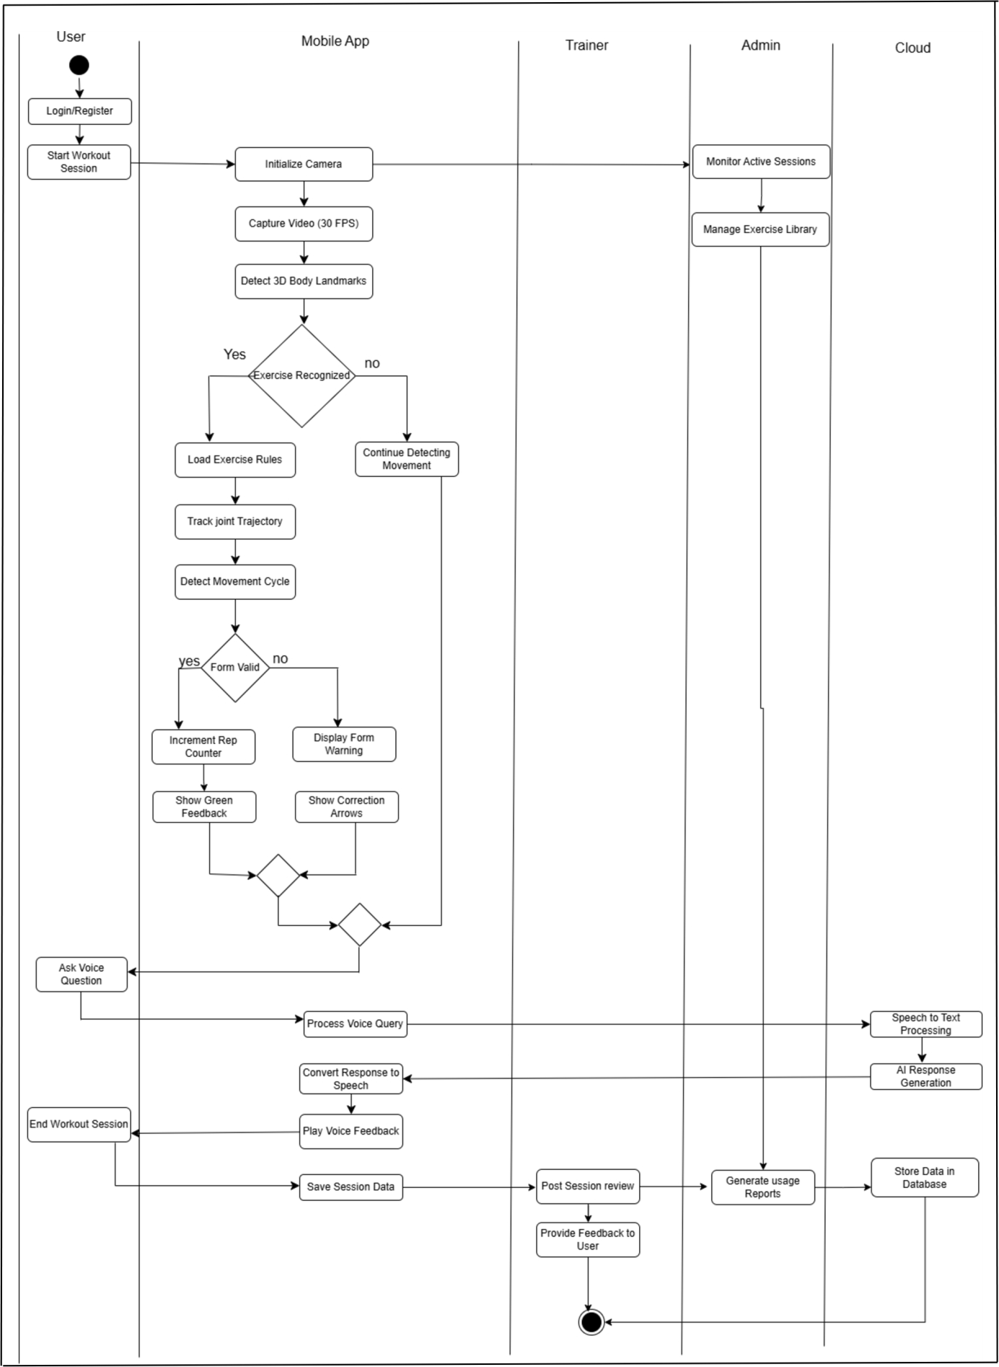
Figure 2: Swimlane Activity Diagram

System Sequence Diagrams:
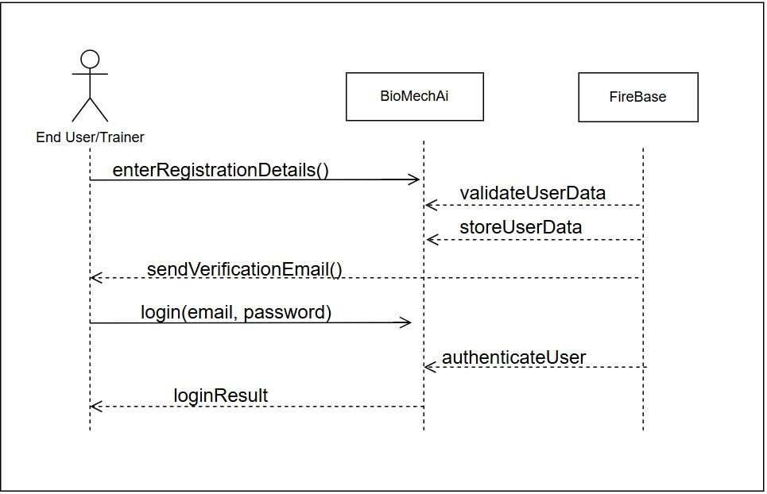

Figure 3: System Sequence Diagram 01 - User Registration and Login

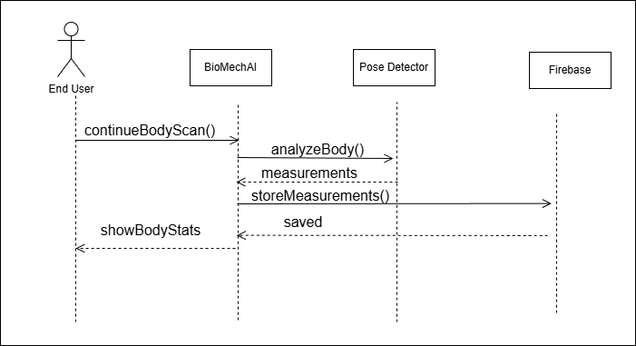

Figure 4: System Sequence Diagram 02 - Body Measurement Tracking

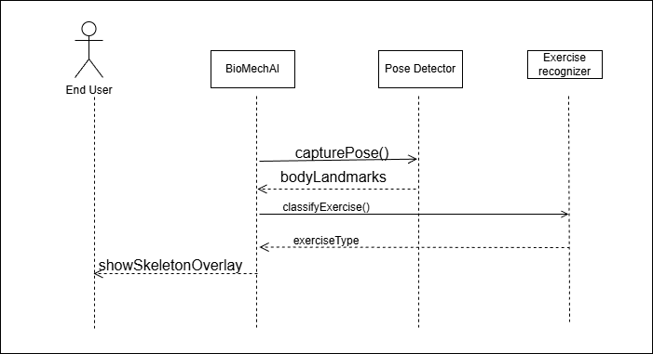

Figure 5: System Sequence Diagram 03 - Exercise Recognition

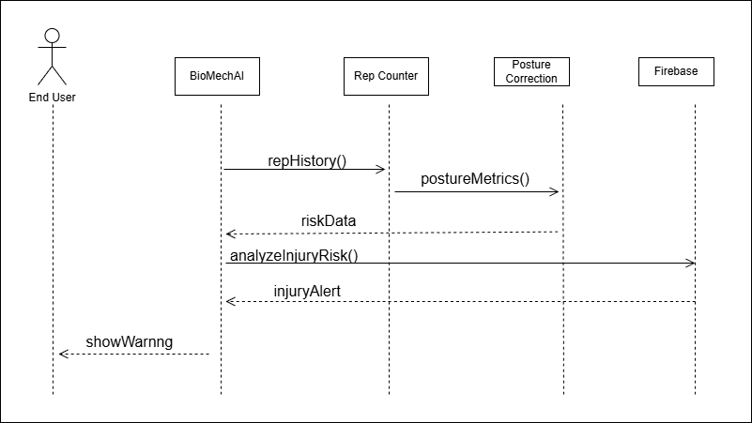

Figure 6: System Sequence Diagram 03 - Injury Prediction

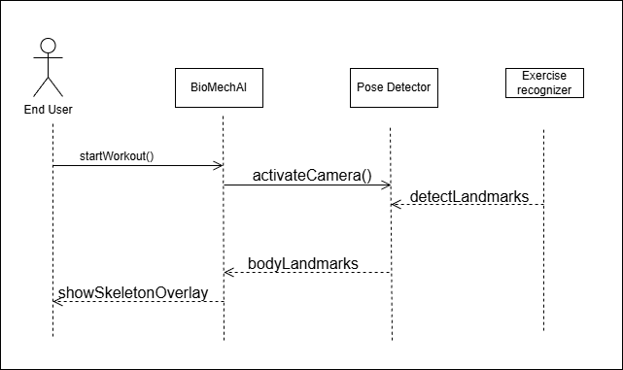

Figure 7: System Sequence Diagram 04 - Pose Detection

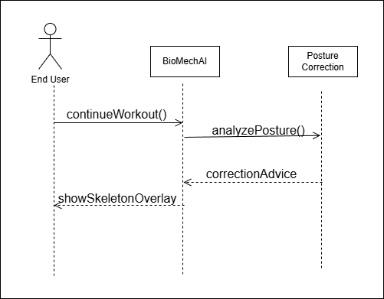

Figure 8: System Sequence Diagram 05 - Posture Correction

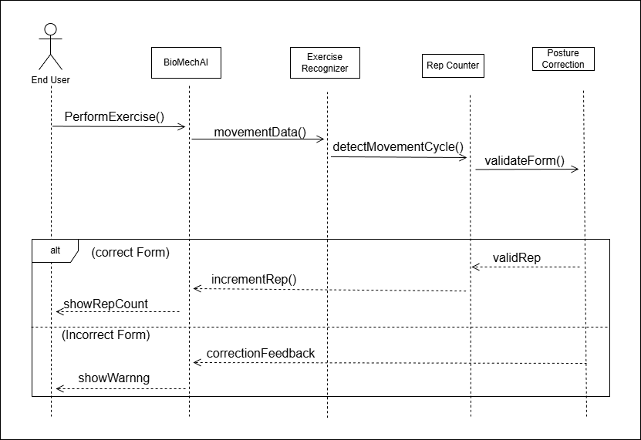

Figure 9: System Sequence Diagram 06 - Rep Counter

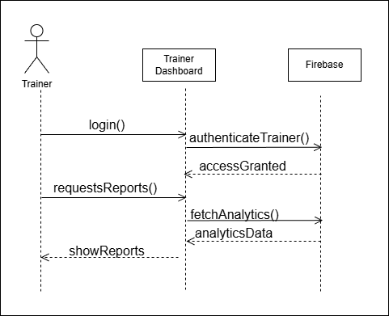

Figure 10: System Sequence Diagram 07 - Trainer Dashboard

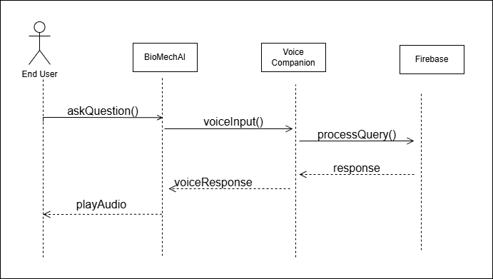

Figure 11: System Sequence Diagram 09 - Voice Companion

Structural Design:

Domain Model:
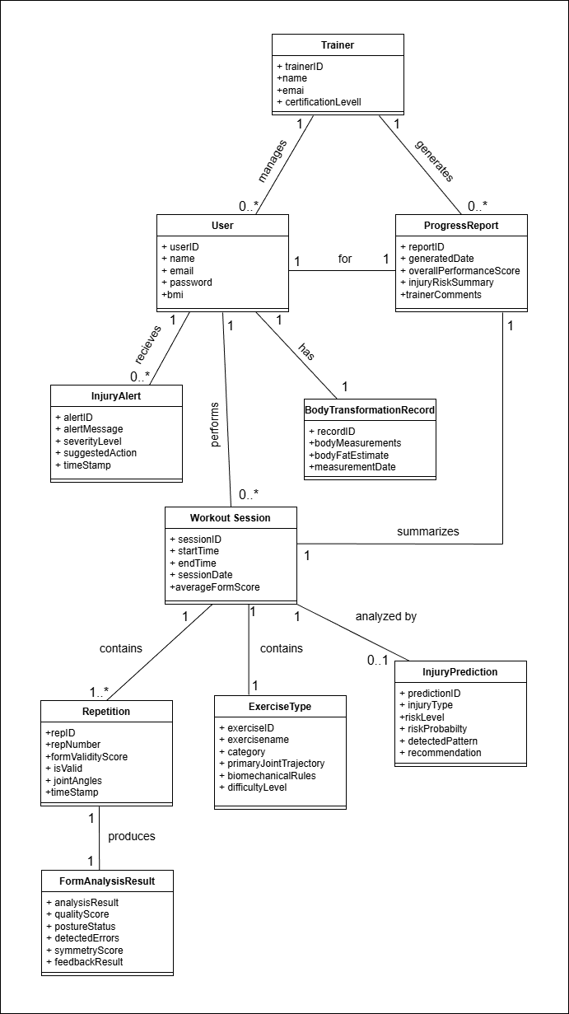
Figure 12: Domain Model

Class Diagram:
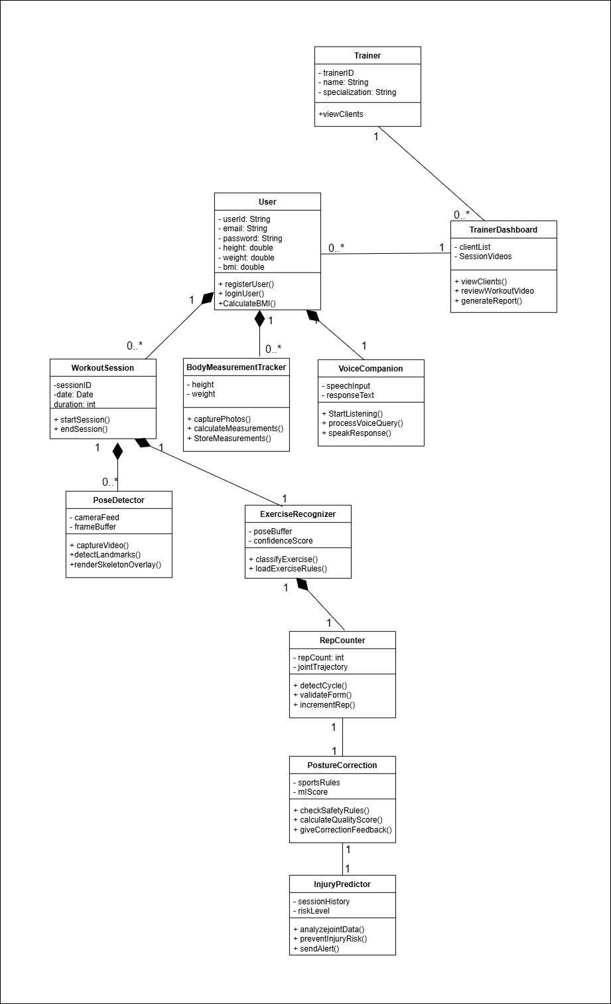
Figure 13: Class Diagram

Component Diagram:
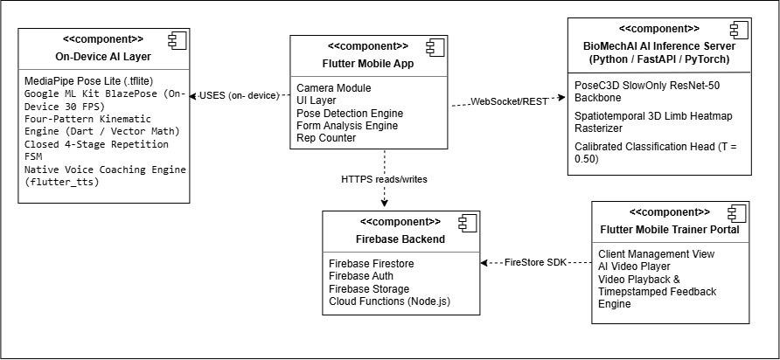

Figure 14: Component Diagram

Behavioral Design:

Data Flow Diagram:
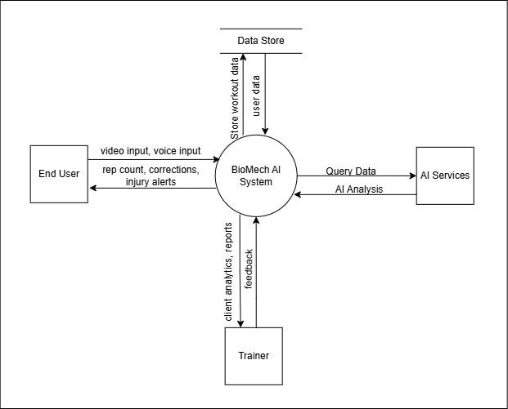

Figure 15: DFD Level 0

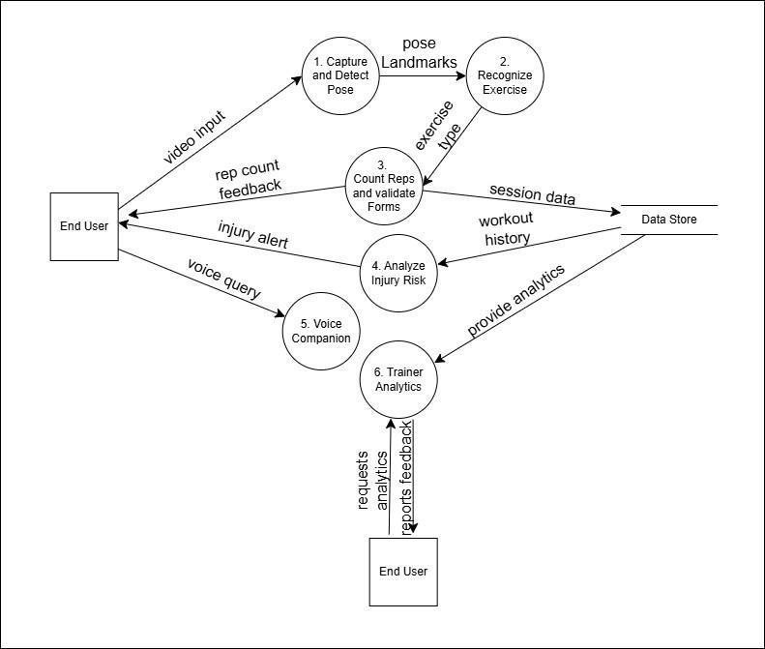

Figure 16: DFD Level 1

State Machine Diagram:
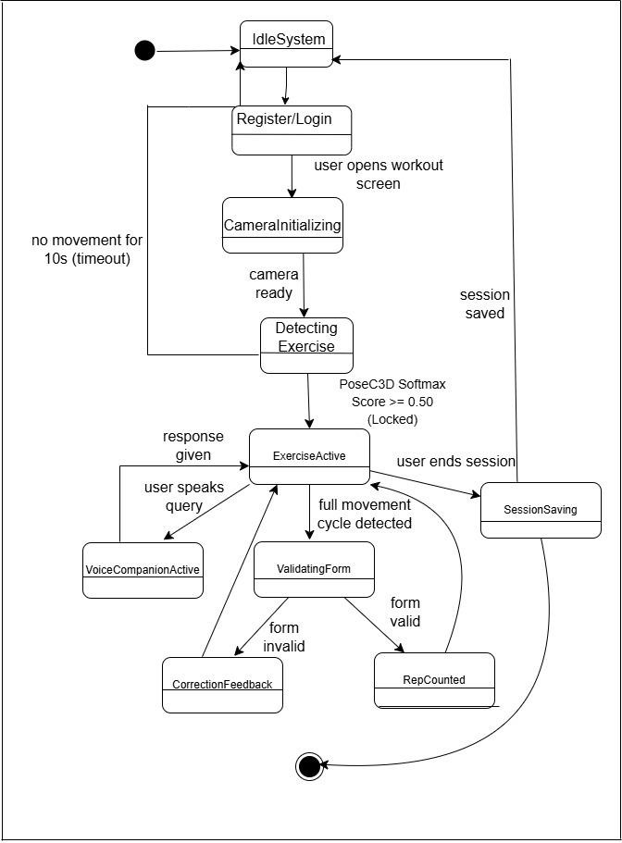

Figure 17: State Machine Diagram

Sequence Diagram:
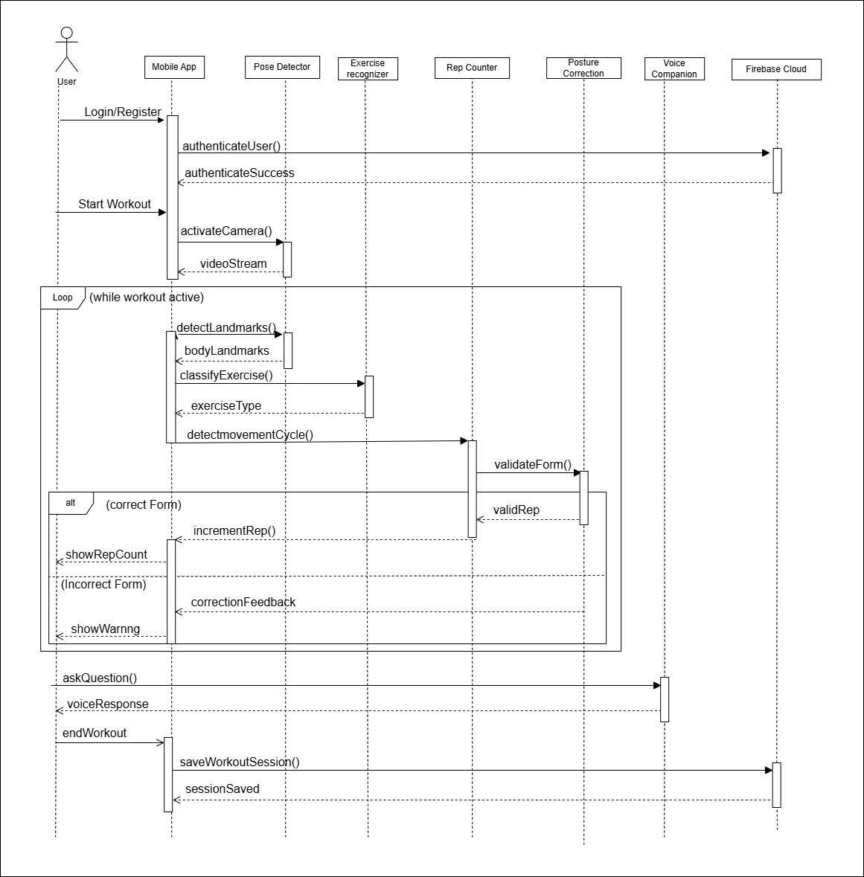
Figure 18: Sequence Diagram

Maintenance Phase:

Deployment Diagram:
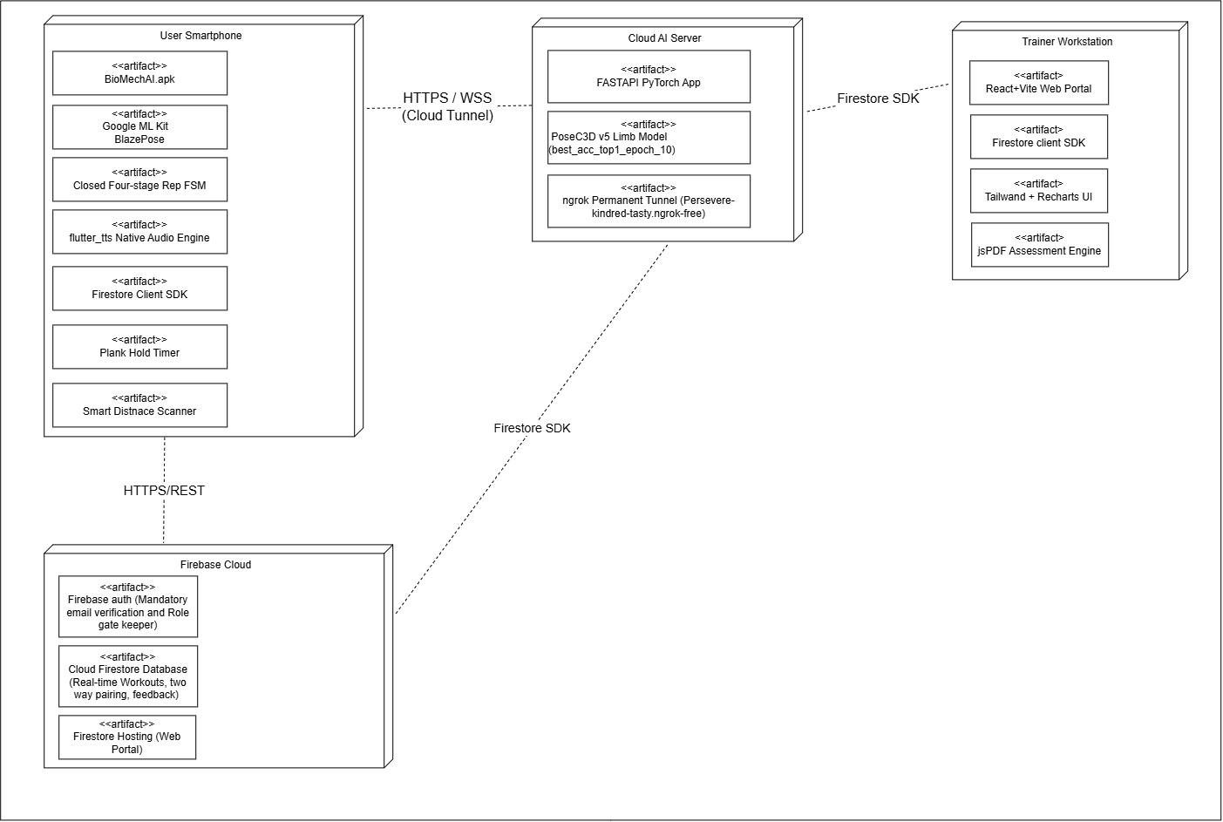

Figure 19: Deployment Diagram

The End

